**Chapter 2**

# Collision Avoidance

The context of Collision Avoidance is introduced in (tab. 2.1), the structure was taken from Gardi [1]. The *state of art* changes was incorporated into the table.

*Function*

*Equipment/Task*

|  |  |
| --- | --- |
| Communication | Telecommunication datalinks,  Controller Pilot Data Link-Control (CPDLC),  Voice Communication |
| Navigation | Navigation sensors including GNSS, INS, etc.  providing 3D/4D navigation capabilities. |
| Surveillance | Cooperative Systems (TCAS, ACAS, etc.)  Non-cooperative Sensors (LiDAR,Cameras, etc.) |
| Situation Awareness | Early Warning Systems,  CDTI Display |
| Autonomous  Decision  Making | Strategic, Tactical, Emergency Flight Planning,  Intelligent Collision Detection,  Conflict Resolution and Prevention,  Weather/Terrain/Constraints Avoidance |

Table 2.1: Collision avoidance systems context overview [1].

## 2.1 Overview

The *Detect and Avoid*, as a part of *Collision Avoidance*, impacts all collision avoidance aspects (tab. 2.1). This work focuses on the *Reach Sets* which gives us the following focus area:

1. *Communication* - it is assumed the command & control communication link is stable. This aspect is not affected by reach sets.
2. *Navigation* - minimal navigation framework needs to be implemented for full experimentation with the navigation capabilities of the *Reach Set* based trajectory generation.

1

1. *Surveillance* - the surveillance will be covered with necessary low-cost technologies, the simulated sensor inputs for following surveillance equipment is considered:
   1. *Non-cooperative* - LiDAR Sensor.
   2. *Cooperative* - ADS-B In/Out.
2. *Situation awareness* - the situation awareness focuses on *space segmentation* and *safety evaluation* to support proper safe trajectory selection from *reach set*.
3. *Autonomous decision making* - the *reach set* covers all possible avoidance strategies, to know how to select proper strategy is key in successfully avoidance maneuvering.

**Communication:** An overview elaboration on capability, reliability, security, architecture have been summarized by Johansen et al. in [2].

The current state of art *communication lines* and relay approaches are sufficient to provide necessary utilities. The use of an existing 4G/3G mobile network is the most probable candidate for low altitude UAS operations. The necessity to build a back-up network for communication is still an open topic.

**Navigation:** An overview is given by Nex [3] *Waypoint planning in a 3D environment* is elaborated in [4]. *Waypoint Tracking and Test Environments* are thoughtfully discussed in [5, 6, 7, 8].

All navigation methods are fairly similar. Consisting of the following steps in the loop:

1. Select goal waypoint.
2. Evaluate feasible navigation strategies (cost function).
3. Select navigation strategy and generate reference trajectory.
4. Follow the reference trajectory with UAS system.

The *evaluation process* and selection criteria need to be designed in the context of *reach sets*.

**Surveillance:** TCAS and ACAS systems cover the cooperative surveillance, an interesting aspect of these systems are *Resolution Advisories* [9] for TCAS [10]. For ACAS. These advisories are giving the suggestions for the pilot to avoid an occurring collision. The responsibility for following advisories and avoiding collision is on the pilot.

This mechanism needs to be changed to increase the determinism of UAS behavior. The voluntary approach of advisories needs to be replaced with a mandatory approach

(directives).

### 2.1. Overview

**Situation awareness:** The aspect of the situation awareness of surroundings has been introduced in [11]. *LiDAR-*based *SAA* system has been introduced by Sabatini [12] further enhanced by Ramasay [13]. Other *Non-Cooperative* sensors and their feasibility have been outlined in Ramasay work [14].

The common ground of these works is an operational space discretization into various forms of finite discrete sets to enable deterministic decision making. The key issue is to find a good rate between space democratization and solution precision. The large cells in the grid usually hide many escape routes. The small cells in grid usually increase the computation complexity and diminish computation time optimal solution.

Examples of *situation awareness:* implementation can be found mainly in *human-centered* systems, *Early Warning System* has been proposed by Lee [15] and an adaptive version by Miller [16]. Effects of *CDTI Display* visualization and human decision impact have been examined by Thomas [17]. *Self Separation* aspect has been examined by Williams [18].

The important concept for *UAS* is internal data representation and autonomous situation resolution. The autonomous situation resolution (decision-making process) can be extracted from human pilot operation procedures.

**Manned Aviation Concepts:** The introduction of necessary concepts from manned aviation is organic in UAS concept understanding. Many of the concepts are taken directly from manned aviation. The main contribution is to change the *human decisions* into *autonomous system decisions*.

**Airspace Classification:** For integration of the UAS systems into non-segregated airspace it is necessary to know the classification of the *operational space*. Who is the authority, in which space, and when the authority is enforced? The general overview of airspace classes and concepts accepted by ICAO/FAA/EASA are outlined in (sec. 2.2). The common viewpoint is emphasized.

**Aircraft Operational Rules:** It is necessary to know the basic rules in controlled/uncontrolled airspace. What is expected to be done by the aircraft in various flight modes. What is minimal equipment’s, what is airworthiness and so on. The basic regulations are outlined in (sec. 2.3). Visual Flight Rules (VFR) interesting parts can be found in (sec. 2.3.1). Instrumental Flight Rules interesting parts can be found in

(sec. 2.3.2).

**Active/Passive Separation and Self-Separation:** The *safe navigation* in *airspace* have multiple levels, going from least strict to very strict and keeping aircraft or UAS *well clear* of all threats. There is first protective barrel known as *well clear*; then there is a smaller protective barrel representing *near miss*, then the smallest protective barrel representing *crash zone*. The *Well clear* state of aircraft/UAS in airspace important parts are mentioned in (sec.2.4).

The important role of *Air Traffic Control* for manned aircraft is introduced in (sec. 2.4.1). The general aviation *routing* principles can be used on the various scale for *UAS routing*. The form of *ATC* commands and directives must persist in future UAS traffic management, for compatibility reasons.

The current Collision Avoidance Systems systems TCAS (2.4.3) and ACAS-X (2.4.2) which can be used as unmanned approach base are introduced.

**UAS Traffic Management:** The traffic management functionality is analyzed in (sec. 2.5), two major movements EU USPACE (2.5.1) and US NASA UTM (2.5.2) exists. The most notable information from operation specification is extracted there.

*Event-Based Avoidance* (sec. 2.6) defines basic event-based control invoked by *UTM*; two major categories are analyzed in *Mid-Air Collision Prevention* (sec. 2.6.1) and *Weather Impact* (sec. 2.6.2).

## 2.2 Airspace Classification

**Motivation:** The *Airspace Classification*, last changed by ICAO in 1990, is described in [19]. The *p*urpose of airspace classification from *collision avoidance perspective* are the following:

1. *Separation* - Maintaining a minimum distance between an aircraft and another aircraft or terrain to avoid collisions. There are following separation types:
   1. *Vertical separation* - to ensure sufficient altitude differences from threats separate those airspace attendants.
   2. *Horizontal separation* - to endure that *airspace attendants* have sufficient horizontal distance from threats
2. Clearance - permission award process by Air Traffic Control (ATC) for an airspace attendant to proceed with flight plan execution/change.
3. *Organization* - ensure that *airspace attendant* can expect a minimal level of separation and airspace organization depending on the type.

*Note.* This work focuses on *separation* in both controlled/non-controlled airspace.

**Airspace Categorization:** The airspace is segmented depending on the *altitude*. The altitude boundaries can be given in one of two ways:

1. *Altitude above Mean Sea Level* (AMSL) - the barometric altitude is used as boundary reference.

### 2.2. Airspace Classification

2. *Altitude above Ground Level* (AGL) - the boundary copies terrain.

There is an example of airspace classification for *Australia*[1] and *Czech Republic*[2]:

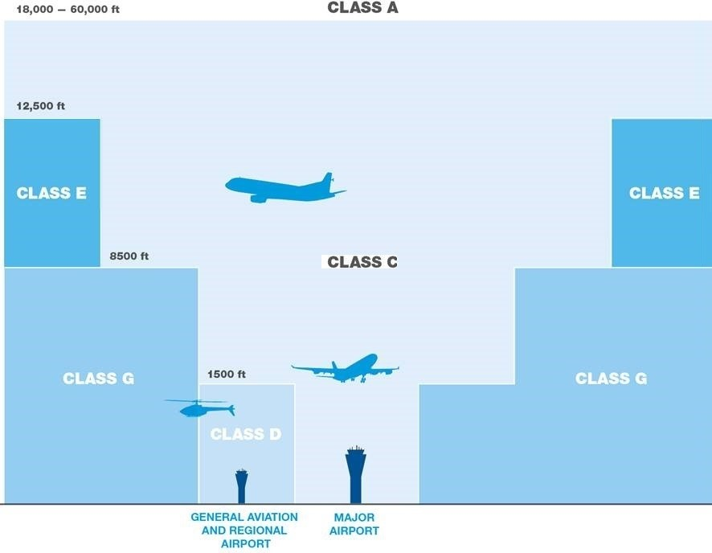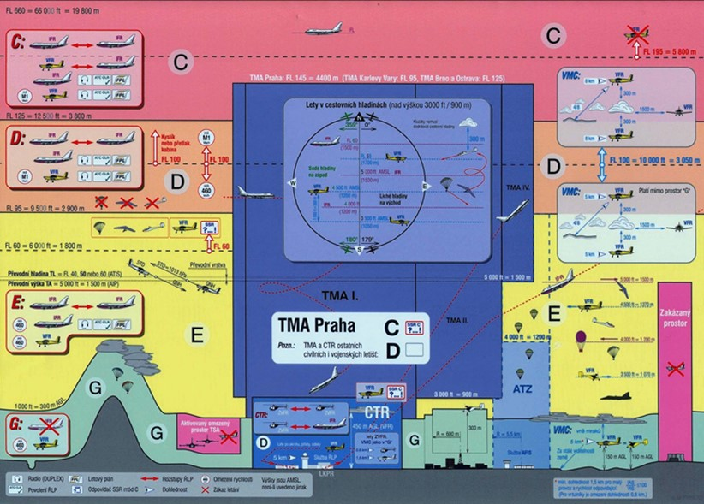

(a) Australian airspace classification. (b) Czech Republic airspace classification.

Figure 2.1: Airspace classification examples.

The *Airspace classes are given like follow*:

**Class A** *(Upper) Operational Airspace* (18 000 - 60 000 feet AMSL) (considered as part of national airport controlled airspace in EU) - the operational airspace where the most of the commercial/military flights are conducted

**Class B** *International Airport Airspace* (0 - 18 000 feet AMSL) (a special class of airports in the U.S., considered as C airspace in EU) - the airspace down to the ground, with stricter preventive measures against mid-air collision and ground collisions.

**Class C** *National Airport Airspace* (0 - 18 000 feet AMSL) - the standard national level airport airspace with preventive measurements against mid-air collision and ground collision situations.

**Class D** *Regional Airport Airspace* (0 - 1 500 feet AMSL) - the *regional airport authority* inactive for the most of the time.

**Class E** *(Lower) Operational Airspace* (1 500 - 12 500 feet AMSL) - the controlled airspace on lower flight levels, lower airworthiness requirements are applied.

**Class F** *(Upper) Uncontrolled Airspace* (500 - 1 500 feet AGL) - the upper portion of uncontrolled airspace (deprecated and merged into E class airspace in most countries).

**Class G** *(Lower) Uncontrolled Airspace* (0 - 500 feet AGL) - the lower portion of *airspace* which is *free to fly*.

*Note.* The *boundaries of the airspace classes* may vary between countries in all segments. The *ATC authority* is usually enforced from *FL-60* (6 000 feet AMSL).

**Airspace Roles and Responsibilities:** The *airspace* characteristics is given in (tab 2.2). The *characteristics* are following for each airspace class:

1. *Controlled Airspace* - indicates if *Air Traffic Control* has authority over the *airspace class, in general,* the airspace classes can be divided into:
   1. *Uncontrolled Airspace* (classes F/G) - the *ATC* have an only advisory role, the responsibility for safe flight is only on the *pilot side*.
   2. *Controlled Airspace* (classes A-E) - the *ATC* have full mandate to issue directives and validate or revoke clearance for pilots action. If the pilot is following ATC recommendation and order to a given *degree of precision,* it should remain safe.
2. *Instrumental Flight Rules* - indication if manned aviation with compliant with IFR requirements can enter into airspace.
3. *Special Visual Flight Rules* - indication if manned aviation with compliant with SVFR requirements can enter into airspace (the U.S. only).
4. *Visual Flight Rules* - indication if manned aviation with compliant with VFR requirements can enter into airspace.
5. *Flight Clearance* - the flight plan approval and flight plan changes are required to enter and operate in a given airspace. The *Flight Clearance* can be:
   1. *Required* - full cooperation with ATC is required.
   2. *Advisory Only* - the ATC provides only flight plan advisories to minimize collision risk, the responsibility for safety and surveillance is on pilot side.
6. *Separation* - the ATC is actively looking for conflict occurrence and changes the *traffic flow* to keep airspace attendants separated.
7. *Traffic Information* - the ATC is providing the *movement and intentions* of air traffic attendants in the given segment to others.

### 2.2. Airspace Classification

Class

Controlled

IFR

SVFR

VFR

ATC

Clerance

Separation

Traffic

Information

|  |  |  |  |  |  |  |  |
| --- | --- | --- | --- | --- | --- | --- | --- |
| A | Yes | Yes | No | No | Required | For all flights | N/A |
| B | Yes | Yes | Yes | Yes | Required | For all flights | N/A |
| C | Yes | Yes | Yes | Yes | Required | For all flights:  IFR/SVFR to  IFR/VFR | Provided:  - all VFR |
| D | Yes | Yes | Yes | Yes | Required | Provided:  IFR to IFR | Provided:   * all VFR * all IFR |
| E | Yes | Yes | Yes | Yes | Required:  IFR/SVFR | Provided:  IFR to IFR | Provided:   * all VFR * all IFR |
| F | No | Yes | No | Yes | Advisory only | Provided:  IFR to IFR | Provided:   * all VFR * all IFR |
| G | No | Yes | No | Yes | No | No | Provided:3   * all VFR * all IFR |

Table 2.2: ICAO airspace summaries [19, 20].

**Example of Airspace Segmentation:** There is an example of an *airspace map* for the Czech Republic[3]. The example snapshot contains (fig .2.2) following elements giving the complex feeling of *National Airspace*:

1. *Active Airports* (red fill circles) - the active B, C, D class airports, with permanent or temporary ATC for IFR/VFR flights.
2. *Inactive Airports* (gray fill circles) - the inactive or without temporary ATC, enabling VFR/IFR operations after ATC clearance from the active airport.
3. *Flight Corridors* (orange boundary polygons) - the permanent/temporary flight corridor in defined flight levels. The flight corridors have time slot reservation and moving along them requires ATC clearance.
4. *Airport Corridors* (aquamarine boundary polygons) - the corridors where entering/leave requires ATC clearance, usually used for climb/descent maneuvers, the higher safety measurements are imposed.
5. *Restricted Airspace* (orange fill polygons) - temporary or permanently banned airspace portions. These areas are established by ATC in cases of emergency or military maneuvers or other special requests.

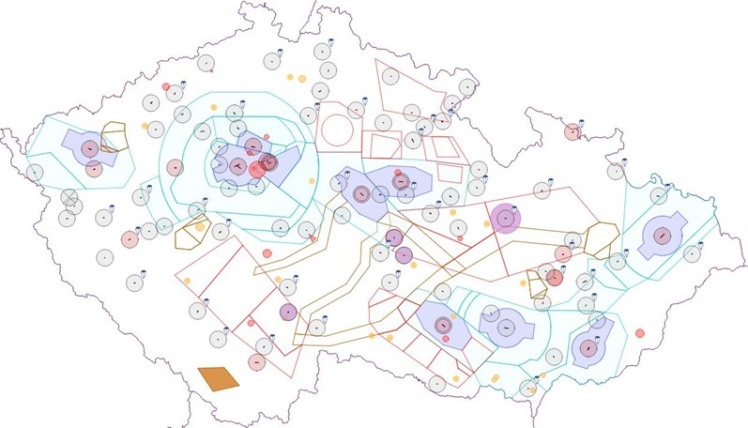

Figure 2.2: Example situation in Czech Republic airspace.

*Note.* Most of the marked zones are restricted for the RPAS/UAS systems. To integrate RPAS/UAS systems, it is necessary to make them compliant with manned aviation regulations and requirements. The impact of RPAS/UAS system failures on human body [21] and *civil airplanes* [22] outlines future integration requirements.

**Aircraft Categorization:** The aircraft categorization for *avoidance priority* is defined in ICAO Annex 2. [23] also known as *aviation classes for immediate avoidance*. This categorization is based on maneuverability:

1. *Manned aviation in distress* - any kind of manned aviation in distress has the highest priority in avoidance.
2. *Balloons* - having only limited vertical maneuverability, impaired by any wind impact significantly, the balloons are avoided by any capable manned aviation.
3. *Gliders* - absence of propulsion impairs vertical avoidance capabilities.
4. *Air fuelling and towing* - dependable load impairs maneuvering capability.
5. *Airships* - limited cruising speed turning angles impairs overall avoidance performance.
6. *Other Manned aviation with propulsion* - normal maneuverability, capable of horizontal and vertical separation

*Note.* This categorization is based on airspace attendant maneuverability

There is also supplemental categorization based on operational approach speed (for manned aviation only) [24] going like follow:

**Class A** *Small single engine* - cruising speed (100 - 110 knots), runway approach speed (70 - 110 knots).

### 2.3. Aircraft Operational Rules

**Class B** *Small multi-engine* - cruising speed (130 - 150 knots), runway approach speed (85 - 130 knots).

**Class C** *Airline jet*- cruising speed (160 - 240 knots), runway approach speed (115 - 160 knots).

**Class D** *Large jet/military jet*- cruising speed (185 - 265 knots), runway approach speed (130 - 185 knots).

**Class E** *Special military*- cruising speed (230 - 275 knots), runway approach speed (155 - 230 knots).

*Note.* The *differences* between cruising speed/runway approach speed are not significant (concerning ratio). The speed does not impact maneuverability as much as propulsion type and steering elements.

## 2.3 Aircraft Operational Rules

**Motivation:** The *aircraft operation rules* are ranging from personal, through technical, to standardization category. In this section, the *flight rules* will be outlined in necessary depth for *collision avoidance*. The goal of this section is to give an overview of airspace constraints.

**Rules Origin:** The *Rules of the Air* are provided by the following documents:

1. *SERA Regulation 923/2012* - laying down the common rules of the air and operational provisions regarding services and procedures in air navigation and amending Implementing Regulation (EU) No 1035/2011 and Regulations (EC) No 1265/2007, (EC) No 1794/2006, (EC) No 730/2006, (EC) No 1033/2006 and (EU) No 255/2010

[25] notable contributions:

* 1. *Table of cruising levels* - Appendix III.
  2. *ATS airspace classes — services provided and flight requirements* - Appendix IV.

1. *SERA Regulation 2016/1185* - Commission Implementing Regulation (EU) 2016/1185 of 20 July 2016 amending Implementing Regulation (EU) No 923/2012 as regards the update and completion of the common rules of the air and operational provisions regarding services and procedures in air navigation (SERA Part C) and repealing Regulation (EC) No 730/2006.
2. *ICAO Annex II.* - the *most accepted* rules of the air document [23], providing general rules of the air (sec. **??**, **??**, **??**).

*Note.* This section contains important parts from previously mentioned documents.

### 2.3.1 Visual Flight Rules

**Motivation:** A *Visual Flight Rules* (VFR) requires the pilot ability to see outside the cockpit to:

1. *Control an aircraft* - to check a responses to control input (UAS self-diagnostic).
2. *Check altitude* - to check and asses an altitude based on the estimated ground distance (UAS - barometric altimeter, ranging sensors).
3. *Navigate* - to steer aircraft for reaching long term goal, including position estimation. (UAS Navigation Module, GPS Module)
4. *Avoid other obstacles and intruders* - see and avoid procedures, following rules of the air in case of intruder avoidance. (UAS Detect And Avoid system).

*Note.* Each of VFR task has an equivalent task in IFR or UAS implementation. The system impact on aircraft airworthiness is interchangeable up to some degree.

**See And Avoid:** The pilot has situations awareness of its surroundings and velocity. The *horizontal/vertical* avoidance maneuvers are executed if necessary.

**Night VFR:** Some countries (ex. the United States) allows flights under VFR when the sun is after horizon (astronomical night). The separation minimums are same. There is a *clear sky requirement* (FAA) which disallows any clouds on higher flight levels.

**Traffic Advisories:** The *United States*, *Australia*, and, *Canada* ATC provides the service of *flight following*. A pilot can request the *flight following* outside the *B, C, D* class airspace, the ATC will communicate possible threats to pilot, the responsibility for safety is on the pilot.

*Note.* The *traffic advisories* are a weaker version of *directives*; they can be used for RPAS systems communication.

**Weather Separation:** VFR Weather Minimums – *Visual Meteorological Conditions* (VMC). Europe currently follows SERA (Standardised European Rules of the Air) rules, which are mostly the same as ICAO rules used throughout the world (local exceptions may apply). Current VFR Weather Minimums are:

1. Altitude: at and above 10000 feet (3000 m), in every class of airspace – flight visibility 8000 m; 1500m horizontally from clouds, 1000 feet (300 m) vertically from clouds.
2. Altitude: below 10000 feet (3000 m) and above 3000 feet (900 m) or above 1000 feet (300 m) above terrain (whichever is higher) in every class of airspace – flight visibility 5000 m, 1500m horizontally from clouds, 1000 feet (300m) vertically from clouds.

#### 2.3. Aircraft Operational Rules

1. Altitude: at or below 3000 feet (900 m) or at or below 1000 feet (300m) above terrain in class A, B, C, D, E airspace (controlled) – flight visibility 5km and 1500 m horizontally from clouds 1000 feet (300 m) vertically from clouds.
2. Altitude: at or below 3000 feet (900 m) or at or below 1000 feet (300 m) above terrain in class F and G airspace (uncontrolled) – flight visibility 5000 m, clear of cloud and with a sight of the surface.

There are exceptions from the last rule. ICAO rules allow for flights (at or below 3000 feet or at or below 1000 feet above terrain in F and G uncontrolled airspace) when flight visibility is no less than 1500m:

1. at speeds that, in the prevailing visibility, will give adequate opportunity to observe other traffic or any obstacles in time to avoid a collision,
2. in circumstances in which the probability of encounters with other traffic would normally be low, e.g., in areas of low volume traffic and for aerial work at low levels

A similar exception (at or below 3000 feet or at or below 1000 feet above terrain) applies to helicopters, which can fly when flight visibility is less than 1500 m.

Refer your country AIP[4] (usually or AIP ENR 1.1) for local restrictions.

*Note.* The clouds are very dangerous for UAS because they impair sensors, causes freezing and damages the on-board electronic, the WMC can be used in *weather safety handling definitions*.

### 2.3.2 Instrumental Flight Rules

**Idea:** The key idea of *Instrument Flight Rules* (IFR) is to provide additional surveillance resulting in better air traffic knowledge, weather and situation awareness.

The situation is different in the case of UAS; single autonomous agent replaces the combination of human pilot decisions and surveillance provided information. The main challenge is to replicate the human pilot data fusion process leading to *situation awareness* and later decision-making process leading to *aircraft control*.

**Instrument Flight Rules:** By definition [23], *Implementation of Visual Flight Rules under the weather or other conditions*. The main goal of IFR is to keep aircraft separated and with clearance.

The *separation* of *aircraft* is the main responsibility of *Air Traffic Control* (ATC) which is providing IFR aircraft with guidance.

There is minimum equipment which needs to be carried by aircraft to be considered IFR airworthiness [20]. The minimal equipment to be carried for IFR flight in European Airspace (EuroControl) is given as follow:

1. *GPS* - mandatory for all flight levels in controlled airspace.
2. *Transmitter* - the way to communicate with ATC/Ground. There can be digital transmitter equipment to receive automatic warnings from TCAS/ACAS systems, *ATC directives*, and, notices to airman (NOTAMS).
3. *Transponder* - the broadcasting device is giving out aircraft position and additional mandatory information. The current plan is to make ADS-B In/Out mandatory for all air traffic attendants.
4. *Barometric Altimeter* - to measure precise AMSL altitude.

*Note.* Carried does not mean used. Most of the pilots in the UK believe that usage of GPS is illegal and they avoid it in small private flights in controlled airspace.

The other popular practice is to turn off the *transponder* because planes tend to hide their position and heading for safety reasons.

**Required Navigation Performance:** The required navigation performance is depending on *flight level* where the *Flight Plan* (Mission) is executed. The *planned trajectory deviation* is the key performance parameter [20].

## 2.4 Separation from Air Traffic

**Remaining ”Well Clear”:** The separation from *air traffic* is an activity when *our airplane* tries to stay away from other traffic in a safe manner.

Before the definition of what is safe, there is a need for some margin definitions around the aircraft. The margins are enclosing a space in the form of a barrel, where *airplane position* is center, the horizontal plane is base for a circular boundary, the vertical axis is base for *distance boundary* (fig. 2.3).

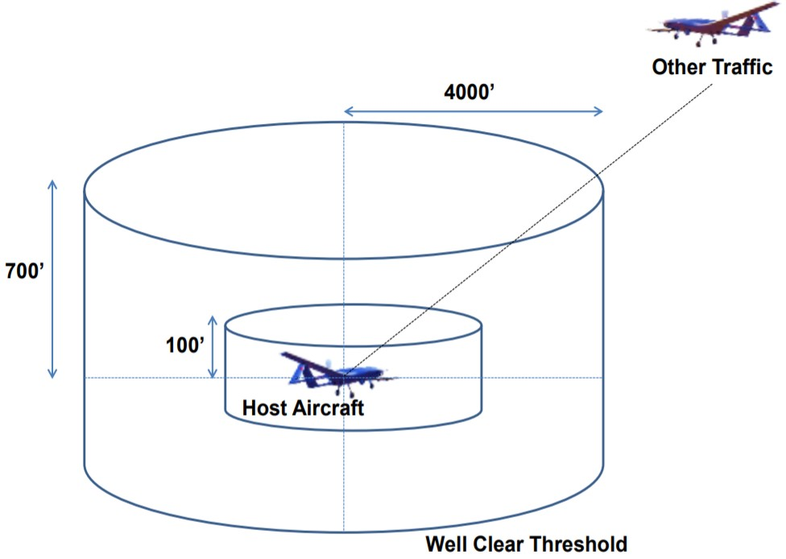

Figure 2.3: Well Clear Threshold [26, 27].

The boundaries and margins classification is taken from [26, 27] and goes like follow:

1. *”Alert”* - the distance to at least one surrounding aircraft is within the *alert margin*; the pilot is alerted about the possible threat, no action is required from the pilot side.
2. *”Well Clear”* - the intruder enters into *well clear range*, the intruder is threatening the *airplane* directly, the pilot is noticed about the security incident.
3. *”Near Miss”* - the intruder gets very close to the *airplane*, the body hit or *turbulence impact* is very probable.
4. *”Body Hit”* - the intruder stuck the *airplane body*.

These incidents are increasing their severity, the goal of separation is to keep every airspace attendant *well clear*, outside well clear threshold (fig. 2.3).

**Air Traffic Control:** The air traffic control has a passive role in separation, it manages the airspace and gives *clearance* for air space users actions. There is active support for VFR (sec. 2.3.1) and IFR (sec. 2.3.2). The role of *Air Traffic Control* is discussed in (sec. 2.4.1)

**ACAS-X/TCAS:** There is support systems fo prevent *Airborne Collision*, which is supporting the *active avoidance* for *IFR* flights (sec. 2.3.2). Their role is to provide the surveillance of *airplane* surroundings and give advisories to pilot. More about next-generation system family ACAS-X can be read in (sec. 2.4.2). The current generation *Airborne Collision* System TCAS is discussed in (sec. 2.4.3).

### 2.4.1 Air Traffic Control

**Motivation:** The modern *Air Traffic Control* (ATC) procedures are outlined in ICAO 4444 [20]. The ATC roles and responsibilities regarding *clearance*, *self-separation*, and, *provided traffic information* are summarized in (tab. 2.2).

The *main role* of *Air Traffic Control* (ATC) is to support the organization of the *airspace* concerning *preemptive* detect and avoid.

*Note.* The *Reactive* and *Event-Based* detect and avoid for manned aviation are covered by *ACAS-X/TCAS systems* (sec. 2.4.2, 2.4.3)

**Commands issued by ATC:** There are multiple levels of commands issued by ATC, their characteristics and the compulsory level is defined as follows:

1. *Notification* - the information notification, commonly known as *NoTice to AirMan* (NOTAM), depending on flight mode, can be transmitted as a voice message or information broadcast. They usually contain information about weather and traffic situation in the given sector.
2. *Warning* - directed message to specific general aviation which may require some direct action. The information is usually informative, but the action is not mandatory.
3. *Recommendation* - directed the message to specific general aviation which requires direct action. The order is usually a specific action, but the action is not mandatory to be executed by the pilot.
4. *Directive* - directed a message to specific general aviation which requires direct action. The order is specific action, and the order fulfillment is mandatory for the pilot.

**Separation enforcement:** The *separation* is the main feature of the ATC in controlled airspace of airports (B, C, D class). Its enforced by the management of *action clearance*. The ATC issues the clearance for take-off/landing sequence.

The clearance for climb/descent is given at the beginning when the flight plan is approved. The ATC issues the time slots for selected pathways. The continuous monitoring of air traffic is executed in periods. The airplane deviation from the cleared plan should be minimal. If there is any incident the *ATC* can take the following actions:

1. *Heading change* - order *general aviation* to change heading in a given time frame (horizontal navigation). This command is usually issued to correct horizontal deviations in path tracking.
2. *Velocity change* - order *general aviation* to change velocity in a given time frame. This command is usually issued to correct time deviations in path tracking.
3. *Altitude change* (Flight Level) - order *general aviation* to climb or descent in a given time frame. This command is usually issued to correct vertical deviations in path tracking (wrong flight level).
4. *Divergence* - order *general aviation* to follow different waypoint in flight plan (goal change). This command is usually used to resolve incidents or to reroute traffic to another hub.
5. *Convergence* - order *general aviation* to return to following original waypoint (goal return). This command is usually used when incident has been resolved in a short time, and the original flight *path* can be re-established.
6. *Restrictions Enforcement* - order *general aviation* to avoid some point with defined distance.

*Note.* All ATC commands can be requested be *general aviation* for clearance to be granted. Meaning the airplane can ask ATC to perform any of the listed actions.

The *separation* can be divided into two distinct types to form *well clear barrel* (fig.

2.3). The separation types are the following:

1. *Horizontal separation* - keep clear of any intruders on the horizontal plane (flight level plane).
2. *Vertical separation* - keep clear of any intruders on given altitude (flight level) range.

*Note.* The *horizontal/vertical* separation is enforced independently, reducing 3D avoidance problem to 2D/1D avoidance problem.

**Traffic Information:** The air traffic information is delivered to general aviation depending on airspace type (tab. 2.2).

*Note.* The *D class* airports usually do not have radar or transponder; therefore, they can provide only visual guidance in altitude/horizontal range around ”control tower.”

**Dynamic Airspace Management:** A real-time *Airspace Management* approach has been presented in [28] following *Dynamic Airspace Management* [29].

The *airspace is usually* divided into the *clusters* where each cluster is managed by separate ATC. When the airplane is leaving one cluster, airplane hand-over is executed.

There is a problem when some airspace cluster is *congested* or overloaded by controlled airplanes. The example of such a situation is given in (fig. 2.4).

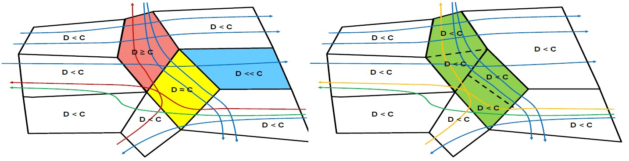

Figure 2.4: Example of DAM flight rerouting to homogenize traffic density [29].

*Note.* The airways cannot be changed, because the real-time change of airways is difficult.

The change of cluster authority is possible because there are no changes for aircraft.

The airspace clusters are divided into three categories (fig. 2.4):

1. *Under-fill* (blue) - there is fewer airplanes than its authority capacity.
2. *Saturated* (yellow) - there is enough airplanes to fill authority capacity.
3. *Over-fill* (red) - there are more airplanes than its authority capacity.

The algorithm [29] will swap some airspace portions between neighboring authorities to balance the load (all authorities should be saturated in ideal conditions) (green) (fig.

2.4).

### 2.4.2 Airborne Collision Avoidance System X

This section follows the summary leaflet [30]. The standard is still under development, the principles relevant for this work are outlined.

**Overview:** A development of *ACAS-X* system is the FAA funded research and development program of a new approach to airborne collision avoidance. It has been ongoing since early 2008. ACAS-X approach takes advantage of years of TCAS development. The main purpose of new system development is the rapid evolution of computational capabilities and the emergence of *Unmanned Autonomous Systems*.

The main purpose for manned aviation is to provide necessary advisories to pilot for *Mid-Air Collision* (MAC) avoidance. There are following improvements:

1. *Reduce Unnecessary Advisories* - The pilot/UAS is receiving avoidance advisories or warning.
2. *Extending collision avoidance to other classes of aircraft* - the current TCAS system is available mainly for bigger manned aviation, the future lies in the integration of UAS systems into non-segregated airspace.
3. *Improvement of Surveillance Environment* - There is development in ADS-B technology and modern non-cooperative sensors like LiDAR or millimeter radar, which are enhancing surveillance capabilities of current and future airplanes.

**ACAS-X variants:** The *ACAS-X* is not universal ”*one-size fits all*” system. There are multiple variations for the different type of aviation:

1. *ACAS-XP* - the general purpose ACAS-X that makes active interrogations to establish the range of intruders. The successor to TCAS II.
2. *ACAS-XP* - a version of ACAS-X that relies solely on passive ADS-B to track intruders and does not make active interrogations. It is intended for general aviation (a class of aircraft not currently required to fit TCAS II).
3. *ACAS XO* - a mode of operation of ACAS X designed for particular operations for which ACAS-XA is unsuitable and might generate an unacceptable number of nuisance alerts (e.g., procedures with reduced separation, such as closely spaced parallel approaches).
4. *ACAS XU* - designed for *Unmanned Aircraft Systems* (UAS).

*Note.* The *ACAS XU* is mean also for *reduced separation* approach in tightly packed airspace (ex. air-taxi). The determinism and *false-positive* alerts occurrence minimization must be assured in order to enable UAS systems into non-segregated airspace.

**ACAS-X Concept:** The *ACAS-X* collision avoidance logic (fig. 2.5) is distinguished into two phases:

1. *Offline development phase* (Pre-calculation) similar to (sec. **??**) - ACAS-X is based on a *probabilistic model* providing a statistical representation of the aircraft position in the future (position cone). It also takes into account the safety and operational objectives of the system (payload/weather/visibility/airspace/aircraft class). This enables the logic to be tailored to particular procedures or *airspace configurations*.

This is fed into an *optimization process* called dynamic programming to determine the best course of action to follow according to the context of the conflict. This takes account of a reward (safety) to the cost (fuel consumption). The concurrent optimization enables to explore multiple maneuvers to determine which will increase the *separation level* (safety) and which will decrease *fuel consumption* (cost).

Key metrics for *operational sustainability* and pilot acceptability include *minimizing* the frequency of resolution advisories (UAS/GA) and traffic alerts (GA). This results into a decrease of reversals/intentional intruder altitude crossing cases.

1. *Real-time operation* (Avoidance run) similar to (sec. **??**) - the *look-up table* is used in real-time onboard the aircraft to resolve conflicts. An ACAS-X system collects *surveillance measurements* form an array of *information sources* and *sensors*. The *situation evaluation* is executed every second (decision time).

Various models are used (e. g. a probabilistic sensor model accounting for sensor error characteristics) to estimate a state distribution, which is a probability distribution over the current positions and velocities of aircraft and intruders. The *state distribution* determines where to look in the numeric look-up table to determine the best action to take. If deemed necessary *Resolution Advisory* is issued to pilots/UAS control module.

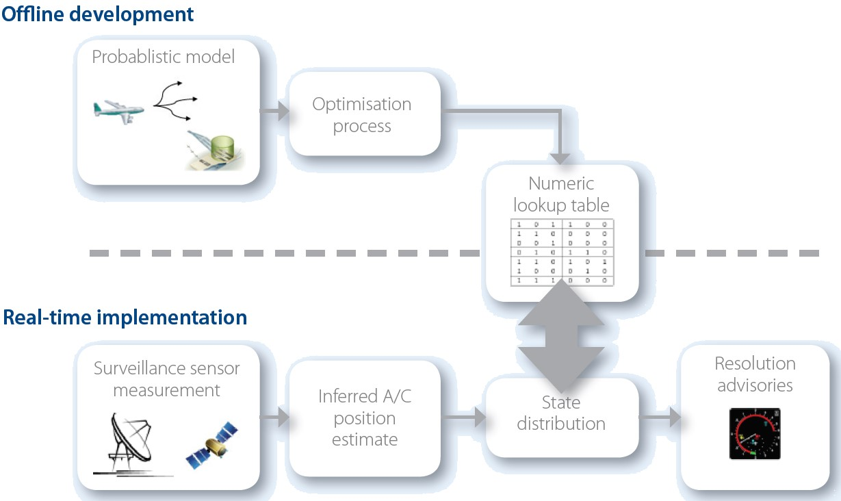

Figure 2.5: ACAS-X concept scheme [30].

*Note. Two-phase calculation* with offline development and real-time operation phase concept will be used differently in our method. (sec. **??**)

**Advisories:** The *ACAS-X* is taking the advisories categorization from *ICAO Annex 10.* [31]. The advisories are recommended (directives for UAS) actions to take.

Airborne Collision Avoidance Systems (ACAS) equipment provides two types of advisories to pilots: Resolution Advisories (RAs) and Traffic Advisories (TAs). These are defined as follows:

1. *Resolution advisory* (RA) - an indication given to the flight crew recommending:
   1. Manoeuvre intended to provide separation from all threats.
   2. Manoeuvre restriction intended to maintain existing separation.
2. *Corrective resolution advisory* - a resolution advisory that advises the pilot to deviate from the current flight path.
3. *Preventive resolution advisory* - a resolution advisory that advises the pilot to avoid certain deviations from the current flight path but does not require any change in the current flight path.
4. *Traffic advisory* (TA) - An indication given to the flight crew that a certain intruder is a potential threat.

*Note.* The *UAS* system with full autonomy must handle the solution of the *directives* (advisories) from UTM and other systems. The example of configurable handling mechanism - *Rule engine* is given in (sec. **??**).

**Example Overview of the Incident:** The *example of the incident* and a resolution is outlined in (fig. 2.6). The *example* is given for a better understanding of *ACAS-X* roles & responsibilities.

1. *Initial state* - the initial state is given like follow:

*Green Airplane* (A/C 1) is cruising on *flight level* FL-390 (39 000 feet)

*Orange Airplane* (A/C 2) is cruising on *flight level* FL-370 (37 000 feet)

1. *Orange aircraft transponder mishap* - the *orange airplane* appears on flight level FL405 (45 000 feet). The *green aircraft* controller (pilot) wants to *descent* to orange aircraft real flight level (FL-370).
2. *Green airplane descent* - the *Green aircraft* starts to descend. The *Orange aircraft* keeps the flight level (FL-370).
3. *Green aircraft Active Surveillance* - the *green aircraft* uses *active surveillance* to detect *orange aircraft*.

The *ACAS-X* issues *Adjust Vertical Speed, Adjust - Resolution Advisory* (AVSA RA) to the *green aircraft* to *level off* and stop *descent* or at least slow it.

Then as *ACAS-X* issues *Climb Resolution Advisory* to the *green aircraft* mandating to get altitude.

*Note.* The main issue is that *pilot* is a responsible decision maker; therefore pilot can refuse to follow *ACAS-X advisories*.

1. *Orange airplane starts descending* - the *orange aircraft* detects the *flight level disparity* due to the *active surveillance* detection of *green aircraft* on *FL-370*.

The *Green aircraft* is tail-gating *orange aircraft* from above. The *ACAS-X* evaluates situation and issues a *Descent Resolution Advisory* to avoid pursuit.

The *pilot* of *orange aircraft* follows the order of RA

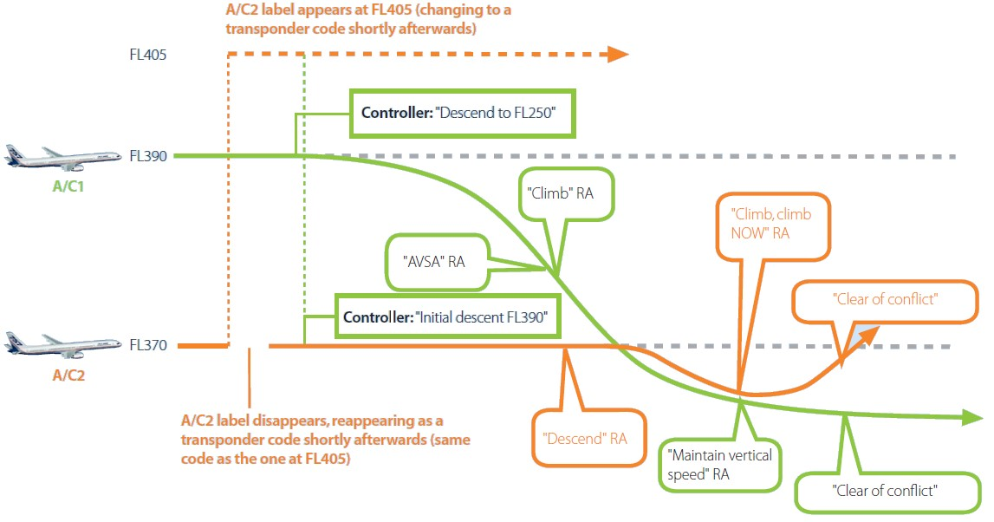

Figure 2.6: ACAS-X incident overview [30].

1. *Tailgating detection* - the *orange airplane* is in front of the *green airplane*, both airplanes are descending at the same rate.

*Note.* This situation is very dangerous because it is very close to *intentional pursuit scenario*.

The *orange airplane* is *pursued*, its *ACAS-X* issues the *Climb Now Resolution Advisory*. The pilot follows the advisory.

The *green airplane* is *pursuing,* and its goal is to *descend* to flight level FL-250. Its *ACAS-X* issues *maintain vertical speed resolution advisory*.

1. *Conflict resolution* - both airplanes follow *Resolution Advisories*. When the significant vertical distance is reached. The conflict is marked as resolved.

### 2.4.3 Traffic Collision Avoidance System

The *TCAS* functionality is equal to ACAS-XA (sec. 2.4.2) functionality. The TCAS II. version 7.1 technical specification can be found in [32]. A *Resolution Advisory* (RA) detection algorithm is outlined in [33].

## 2.5 UAS Traffic Management

**Introduction:** This section strongly follows [34], which outlined the basic concept of operations for Remotely Piloted Aerial Systems (RPAS)/Unmanned Autonomous Systems (UAS) Air Traffic Management (ATM) (later re-branded as UTM).

The *RPAS/UAS* integration into *non-segregated airspace* follows the general manned aviation procedure:

→ For the selected type of Operations VLOS/BVLOS/VFR/IFR:

→ For the selected class of Air traffic (class 1. - class 7):

→ For a selected class of airspace (class A - class G):

→ Deliver Operation Performance Standards (≥ General Aviation)

The prototype of regulation for *RPAS/UAS* standard from EASA can be found at [35]. The section will continue with an outline of important functionality.

**Airspace Assessment:** The future *UTM* must be capable of *airspace* assessment. In manned aviation, the *airspace assessment* is normally triggered by either rise of traffic, environmental issues, capacity issues, and safety concerns or adapting the design to meet forecasted demands.

Presently RPAS/UAS operations have not triggered an airspace assessment s most areas are indicated as *no RPAS/UAS zones*. The *restricted areas* are already known on aviation maps (airport, nuclear power station, etc.). However, there are similarities with RPAS/UAS operations below 500 ft (AGL), that can trigger this requirement for an airspace assessment like, but not exclusive:

1. *The increase of operations density* - UAS taxi can lead to an increase in traffic density in class C and F airspaces, the UAS delivery system can lead to increased traffic density in F class airspace.
2. *Introduction of BVLOS, autonomous VLOS/ELOS/BLOS operations* - current RPAS/ UAS operations are limited to VLOS which limits operation space. When this limitation is lifted, new business cases will open, leading to an *increase* of RPAS/UAS traffic.
3. *Safety Concerns* - there is not enough accidents or critical RPAS/UAS misuse cases, to increase safety concerns, especially G class airspace does not have many manned aviation parallels.
4. *Environmental Aspect* - the RPAS/UAS is not constructed from clean and safe materials, any accident can lead to serious habitat damage (ex. gasoline in water reservoir).

The *assessment* should develop a new type of airspace organization able to cater to the new demand of operations and ensure safety levels are met. The airspace assessment can take into considerations the following aspects:

1. *Airspace classification* - further airspace decomposition in F/G uncontrolled airspace to establish *flight routes* and controlled areas. Further flight levels in C class airspace segmentation to enforce manned/unmanned aviation separation.
2. *Traffic complexity and density* - the *congestion* of traffic is very common on the road. The capability to stop or stay still in the air is very costly to implement and maintain both in manned/unmanned aviation.
3. *Geographical situation* - flat-lands vs. mountains, urban vs. rural areas.
4. *Privacy* - in *very low altitude* operations the privacy is always a concern. The current restrictions to flew over private properties needs to be lifted in order to enable increased higher traffic density.
5. *Security* - the *UTM* and *RPAS/UAS* systems are creating a network of *autonomous agents*; this network is venerable to any kind of *cyber/physical* threat.

**Types of RPAS/UAS operations:** The *future UTM functionality* must cover a wide range of functionality. It is envisaged that RPAS/UAS will operate in a mixed environment adhering to the requirements of the specified airspace it is operating in. RPAS/UAS will be able to operate as follows:

1. *Very low level (VLL) operations* (*<* 500*feet*(*AGL*)).
2. *IFR (Instrument Flight Rules) or VFR (Visual Flight Rules)* (500*feet* ≤ *altitude <* 60000*feet*(*AMSL*)) - following the same rules that apply to manned aircraft. These can be conducted in RLOS or B-RLOS conditions.
3. *Very High Level operations (VHL suborbital IFR operations above FL600)* (≥ 60000 *feet* (*AMSL*)).

**VLL operations (Below 500 feet AGL):** Operations performed at altitudes below 500 feet are not new to manned aviation as many operators - police, armed forces, balloons, gliders, training crafts, fire-fighting, ultra-light aircraft are allowed to operate in this environment. The rule allows VFR traffic to operate, under specific conditions prescribed by the competent national authorities, conditions that can differ from State to State. RPAS/UAS operating in this volume of airspace do not however confirm either IFR or VFR as set in ICAO Annex 2. [23].

1. *VLOS (Visual Line Of Sight)* - RPAS/UAs operations within 500 meters range and max 500 feet altitude from a pilot. One of the main responsibilities of the pilot is the safe execution of the flight through visual means. The distance can be increased by the use of one or more observers, sometimes referred to as Extended-VLOS (E-VLOS).
2. *BVLOS (Beyond Visual Line Of Sight)* - RPAS/UAS operations beyond 500 meters range but below 500ft. BVLOS does not require the operator to ensure the safety of the flight visually, and technical solutions such as DAA and C2 data link are required. RPAS/UTM does not adhere to VFR or IFR requirements; however, it is foreseen that these flights could be conducted in IMC or VMC conditions. BVLOS operations are already being conducted in several States. Some examples are:
   1. Power-line control.
   2. Maritime surveillance.
   3. Pipeline control.
   4. Agriculture.

*VLL Management System:* In order to accommodate the expected growth of traffic in this airspace and ensure a sufficient level of safety, it is anticipated the necessity for a supporting UTM system. This VLL Traffic Management system will provide a series of localization and information services, aiming to the provision of information to the RPAS pilots and manned traffic. The VLL UTM system will not provide an active control service for RPAS in a normal ATC fashion, due to a large number of RPAS/UAS involved. Such a system could be based on existing technologies, such as the mobile phone network. Specific RPAS/UAS reporting systems, providing authorization and information capability, are already in use in several states.

The RPAS/UAS management system will have to cater to the following aspects:

1. RPAS/UAS Flight planning.
2. RPAS/UAS Flight authorization.
3. Real-time RPAS/UAS tracking capability.
4. Provision of actual weather and aeronautical information.

As previously mentioned, it is envisaged that the VLL management system will not support the active controlling of RPAS/UAS at lower altitudes. The large number of RPAS/UAS will not make this possible, notwithstanding any liability aspects. The system will be supporting operations and will be able to provide sufficient data to safely execute an RPAS/UAS flight, based on the information available to it. Data required could include, but are not limited to:

1. Planned flight plans.
2. Active RPAS/UAS flight plans/missions.
3. Airspace data.
4. NOTAM (NOtice To AirMan).
5. Weather.
6. Geo-fencing.
7. Manned operations below 500 feet (AGL).

The following assumptions have been made for future ATM/UTM systems:

1. A C2 service is provided.
2. The State has executed airspace, and assessment geo-fencing is in place.
3. RPAS/UAS have surveillance capability similar concerning performance and compatible to manned aircraft surveillance capability.
4. Specific RPAS/UAS traffic management system is in place.

*Note.* RPAS/UTM vehicle categorization is outlined in *U-SPACE section* (sec. 2.5.1).

The classification of traffic in this airspace segment goes like follow:

**Class I.:** Class I traffic is primarily reserved for RPAS Category A (buy and fly). In areas of low traffic density this class can operate from the ground up to 500ft and is a subject to the following requirements:

1. Mandatory declaration of operation.
2. RPAS must be capable to self-separate in 3D.
3. VLOS operations only.
4. Geo-fencing capability which ensures that this category remains separated from no-drone zones.

**Class II.:** Class II traffic operates in free flight due to the nature of their operations like Surveys, filming, search and rescue and other operations that have no fixed route structure. Class II can operate from the ground up to 500 feet (AGL) and is a subject to the following requirements:

1. Mandatory authorization for operation.
2. Surveillance capability (C2 4G chip or other means).
3. VLOS and BVLOS operations.
4. Free flight Capability.
5. RPAS/UAS must be capable to self-separate in 3D.
6. BVLOS will have barometric measurement equipage.

**Class III.:** Class III traffic only operates in BVLOS and is mainly used for transport purposes. It can operate as free flight or within a route structure pending on the requirements set by the airspace assessment.

1. Mandatory authorization for operation.
2. Has surveillance capability.
3. BVLOS operations only.
4. Free flight or route structure.
5. Shall have barometric measurement equipage.
6. Can operate from the ground up to 500 ft.

**Class IV.:** Class IV traffic can operate within the layer between the ground and 500 feet. This category is designed for highly specialized operations and as such not many of these types RPAS/UAS are expected. These can be civil, state or military operations and as such:

1. Require special authorization.
2. Should be addressed on a case by case basis.
3. VLOS and BVLOS.
4. Could require surveillance capability.

**IFR/VFR Operations (between 500ft - FL 600):** For RPAS/UAS to fly either IFR/VFR requires that they meet the airspace requirements as set for manned aviation. These operations include airports, TMA and Enroute. For IFR capable RPAS additional requirements can be set for flying in the volumes of airspace where normal transport aircraft operate. As such it is envisaged to have minimum performance standards for elements such as speed, climb/descent speed, turn performance and latency.

*Operations of Small RPAS above 500 feet:* In principle operations above 500 feet by small RPAS/UAS are not allowed unless they meet the IFR/VFR airspace requirements and have a solution to be visible to manned traffic. Other aspects like wake turbulence and separation standards would also have to be addressed. However, States can still on a case by case basis accommodate RPAS/UAS above 500ft if the risk assessment of the intended operation is acceptably low.

The classification of traffic in this airspace segment goes like follow:

**Class V.:** Class V is IFR/VFR operations outside the Network not flying SIDs and STARs. In this environment, RPAS/UAS not meeting Network performance requirements will be able to operate without negatively impacting manned aviation. Operations at airports will be accommodated through segregation of launch and recovery.

Ground operations can also be accommodated through either towing or wing walking.

Operations from uncontrolled airports or dedicated launch and recovery sites are to be conducted initially under VLOS/VFR until establishing radio contact with ATC.

No additional performance requirements will be set in this environment compared to manned aviation.

RPAS/UAS operating in the environment will file a flight plan including information such as:

1. Type of RPAS/UAS, 2. Mission plan, 3. Contingency procedure.

1. RPAS/UAS will meet CNS airspace requirements.
2. RPAS/UAS will be able to establish two-way communication with ATC/UTM if required.
3. RPAS/UTM will remain clear of manned aircraft.
4. RPAS operator must be able to contact ATC/UTM (if required) regarding special conditions such as data link loss, emergency, controlled termination of flight.
5. RPA/UTM DAA capability will be cooperative with existing ACAS systems.

**Class VI.:** Class VI. is IFR operations, including Network, TMA and Airport operations with RPAS/UAS capable of flying SIDs and STARs as designed for manned operations. These are either manned transport aircraft enabled to fly unmanned with similar capabilities or new types able to meet the set performance requirements for the Network, TMA and airports. General requirements RPAS/UAS operating in this environment will file a flight plan (mission) including:

1. Type of RPAS/UAS.
2. Contingency procedure.
3. Mission plan (navigation, route, level).
4. RPAS/UAS will meet CNS airspace requirements.
5. RPAS/UAS will be able to establish two-way communication with ATC/UTM.
6. RPAS/UAS operator must be able to contact ATC (if required) regarding special conditions such as data link loss, emergency, controlled termination of flight.
7. RPAS/UAS DAA capability will have ACAS functionality.

*Note.* The class operation class *V.* − *V I.* is covered mostly in this work.

**VHL operations (Above FL 600):** Suborbital unmanned flights operating at altitudes above FL 600 are expected to grow fast in numbers. Apart from military HALE RPAS, several other vehicles (i.e., space rockets, Virgin Galactic, etc) operate through or in this block of airspace. At this moment, no management of this traffic is foreseen in most parts of the world. Particular attention should be given to the entry and exit of this high altitude volume as they need to interact with the airspace below.

The classification of traffic in this airspace segment goes like follow:

**Class VII.:** Class VII consists solely of IFR operations above FL600 and transiting non-segregated airspace.

These types of RPAS/UAS are solely designed for operations at very high altitudes. The launch and recovery of fixed-wing RPAS/UAS can be from dedicated airports and outside congested airspace unless Class VI requirements are met. This airspace will be shared with many different RPAS/UAS. Although their operations will not directly impact the lower airspace, however, they will have to transit through either segregated or non-segregated airspace to enter or exit the airspace above FL 600.

For such cases, temporary segregated airspace should be considered. Transition performance in segregated or non-segregated airspace below FL600 will be very limited since they will be focusing on long missions (up to several months).

The airspace in which these types of operation take place is mostly seen as uncontrolled. This requires no management of this traffic; however due to the expected numbers - estimated to be around 18000 just for Google and Facebook - it will become necessary to manage this type of operation since the performance envelopes differ a lot. Speeds can vary from average wind speed at those altitudes (for Google balloons) up to above-mach.

Launch and recovery of unmanned balloons or aircraft, together with emergency situations, will also require a set of procedures and pre-arranged coordination capabilities to ensure the safety of traffic below this altitude.

### 2.5.1 U-Space

The *Concept Of OpeRations of U-Space* (CORUS) [36] has been released recently. This concept describes the difference between the standard ATM and proposed European UTM solution. This section will get through the interesting part of this pivotal document.

The *U-space* is separated into following functionality based phases:

U1 (year *<* 2020) - sets the scene with registration and geo-fencing.

U2 (year*<* 2025) - introduces tracking, flight planning and messages sent to the remote pilot during flight.

U3 (year*<* 2030) introduces collaborative detect and avoid and tactical conflict resolution.

U4 (year *<* 2035) brings safe interoperation with manned aviation.

The *Aspects* important for *Obstacle avoidance* will be outlined and discussed over this section. Our work focuses on *European Airspace* (EASA); therefore more focus will be on *U-space*

**Small UAS Classification:** Manned aviation is covered by existing rules, for example [23, 37]. Excluding some specific situations, manned aviation does not fly below VFR airspace, do not enter *very low level* (VLL) altitudes [38].

The certified airworthiness is mandatory for *airspace attendants* with *Maximum TakeOff Mass* (MTOM) over 150*kg*. The other *airspace attendants* need to fulfill only *Minimal Operation Performance Specification* (MOPS).

In [39] EASA proposed several classes for UAS below 150*kg* MTOM; see Appendix 1 of the annex to Opinion 1-2018 entitled ...on making available on the market of unmanned aircraft intended for use in the ‘open’ category and on third-country UAS operators. In that text, the next smaller mass mentioned below 150kg is 25kg MTOM. A similar break is proposed in some national legislation, for example in the UK at 20kg. As a working definition, this little chart shows a possible breakdown by MTOM. Note that EASA classes depend on many factors, not only MTOM.

EASA

class

Maximum

take-off mass

Remarks

|  |  |  |
| --- | --- | --- |
| C0 | ≤ 250*g* | ”Child‘s Toy” with very limited capabilities |
| C1 | ≤ 900*g* | ”Adult‘s Toy,” small flying camera |
| C2 | ≤ 4*kg* | ”Small UAS” with the package |
| C3 | ≤ 25*kg* | ”Standard UAS”, attainable AGL altitude ≤ 120*m* |
| C4 | ≤ 25*kg* | ”Standard UAS”, no automatic control mode altitude *>* 120*m* |
| - | ≤ 150*kg* | ”Heavy UAS,” not defined in [39] |
| - | *>* 150*kgkg* | Regulated by EASA in the same manner than manned aircraft [38] |

Table 2.3: Small UAS Classes according to EASA. [36]

*Note.* The class C3 and C4 are different in operational restrictions. This work focuses mainly on UAS classes C2/C3/C4 because they have enabled *automatic control mode*

**Separation Minima:** The *Separation Minima* defines *minimal distances* between airspace attendants to ensure secure *operation*. The separation minima are taken from Corus [36].

All ideas for safe concurrent operation of UAS are based on the idea of keeping the UAS systems apart or physically distant from some risk source.

A geo-fence, for example, is simply a method of providing separation. There will need to be separation minima for UAS just as there are for manned aircraft and these will be needed by services such as Monitoring which seeks to warn about the loss of separation and Tactical Conflict Resolution which may act to avoid loss of separation.

Separation minima will be different from those for manned aircraft as small UAS systems are generally much smaller and often slower moving than manned aircraft. CORUS

proposes the following as separation minima (tab. 2.4)

Flight Type

Interaction

Horizontal

Vertical—

Remark

|  |  |  |  |
| --- | --- | --- | --- |
| Any UAS - Manned or  person carrying | 2.5 NM | 500 ft | Half the current manned aircraft separation |
| VLOS - VLOS | Remain  ”Well Clear” | Remain  ”Well Clear” | The remote pilot is not expected to judge distance by sight from the remote piloting position. |
| VLOS - BVLOS | Remain  ”Well Clear”  + 200 ft | Remain  ”Well Clear”  + 200 ft | The remote pilot is not expected to judge distance by sight from the remote piloting position. |
| BVLOS – BVLOS | 200 ft | 150 ft | Figures come from a pessimistic estimate of satellite navigation performance. |

Table 2.4: Proposed separation minima for UAS. [36]

*Note.* The *BVLOS – BVLOS* separation minima are interesting us because the *autonomous mode* is considered as BVLOS to BVLOS avoidance in case of autonomous UAS.

The *separation minima* for *UAS - Manned aviation* is unreasonably huge (2 nautical miles), and in current it should be considered as moving constraint.

**Flight Rules:** The *aspects* of UAS flight rules for U-SPACE concept is summarized in the table:

Aspect

UAS Flight Rules

|  |  |
| --- | --- |
| Flight plan required | Yes |
| Allowed flight type | VLOS, EVLOS, BVLOS |
| Provision of separation in U1,  VLOS & EVLOS | Pilot |
| Provision of separation in U1,  BVLOS | Geo-fence / Geo-cage |
| Provision of separation in U2 | 1.Strategic Conflict Resolution enabled by flight planning  2.Traffic Information Service enabled by position reporting  3.Pilot (visual) |
| Provision of separation in U3 &  U4 | 1.Strategic Conflict Resolution enabled by flight planning  2.Traffic Information Service enabled by position reporting  3.Cooperative Tactical Conflict Resolution  4.Detect and Avoid  5.Pilot (visual) |
| Separation from manned aviation in U2, VLOS or EVLOS  UAS flight | The pilot is responsible to get the UAS out of the way of the manned aircraft. |
| Separation from manned aviation in U2, BVLOS UAS flight | Flight plan required from both.  Separation by planning. BVLOS pilot should use traffic information to avoid the manned aircraft (which is tracked). |

Table 2.5: Aspects of UAS flight rules.[36]

Following *detect and avoid* requirements can be outlined based on (tab. 2.5).

1. *Separation in U1* - only *identification services* are provided in this phase. The *Detect And Avoid* support can be provided only to UAS pilot in the form of visual or sound advisories.
2. *Separation in U2* - the *position notifications* are added, enabling, preemptive collision avoidance by flight planning (mission control). The *traffic information* can be added to pilot software for better situation awareness.
3. *Separation in U3 & U4* - the *advanced* avoidance concepts, from our perspective following aspects are interesting: a *Cooperative Tactical Conflict Resolution* - The UTM infrastructure and hierarchy for *cooperative conflict* resolution must be established. In form of UTM *directives* and UAS *fulfillment*.

b *Detect and Avoid* - reactive obstacle/intruder avoidance and situation awareness on a very high level.

1. *Separation from Manned Aviation* - the *well clear threshold* (fig. 2.3) for manned aviation (tab.2.4) are too big. The *effective* application of *reactive obstacle avoidance* is not reasonable, because the manned aviation will be out of range for most sensors (except ADS-B).

*Note.* Our work covers *cooperative conflict resolution* and *detects and avoid*.

**Geo-fencing Modes:** A Geo-fencing appears in U1, U2, and U3 and is successively refined. It is supported by aeronautical information for UAS systems. This table summarizes the different features by level:

Capability

Level

Features

|  |  |  |
| --- | --- | --- |
| Pre-Tactical  Geo-Fencing | U1 | Information provided before flight. The user should have access to AIP and NOTAM defined geo-fences in a form that can be used when planning and that can be loaded onto the UAS if it has geo-fence fence features in its navigation system |
| On-board  Geo-Fencing | U1 | The ability of the UAS to keep itself on the correct side of a geo-fence by having geo-fence definitions (location, time, height) within its navigation system |
| Tactical  Geo-Fencing | U2 | This service delivers to the pilot and /or UAS operator updates to and new definitions of Geo-Fences occurring at any time, including during flight.  The creation of geo-fences with immediate effect require that they are defined outside the AIP. |
| UAS  Aeronautical  Information  Management | U2 | U2 include a non-AIP repository of Geo-Fences. The UAS Aeronautical Information Management service includes all information coming from such a source, combined with information from the AIP and NOTAMS together with any other UAS relevant sources. |
| Dynamic  Geo-Fencing | U3 | This service delivers updates definitions of geo-fences directly into the UAS, even in flight. This service relies on capabilities of the UAS in U3 to receive communications from U-space and to deal with geo-fence updates. |

Table 2.6: Geo-fencing in U-space. [36]

The *impact of geo-fencing* on *Detect and Avoid* system is following:

1. *Pre tactical* - The *flight plan* (mission) is prepared to avoid all *known forbidden areas*. In this phase, the geo-fence covers static space constraints.
2. *Onboard* - The *flight plan* (mission) specification does not contain all static space constraints. These constraints are known prior the flight. If UAS approaches such constraints, it needs to avoid them. The concept of soft constraints - restricted, but breakable space constraints emerge.
3. *Tactical* - The *space constraints* are updated during the flight. This can also be used for notifying the weather situations, restricted airspace, and all sort of *static or moving constraints*.
4. *Dynamic* - The *space constraints* the updates are real time.

*Note.* The work covers dynamic and tactical *Geo-fencing*.

**Actively maintaining separation during flight:** The standard ATM functionality [20] and *Rules Of the Air* [19, 23] are covered and to be implemented for *U-Space*.

### 2.5.2 NASA UTM

The *NASA UTM*[5] is UAS Traffic Concept developed by *National Aeronautics and Space Administration* (NASA) in cooperation *Federal Aviation Administration* (FAA). The *concept* is very similar to *EASA U-SPACE*.

*Note.* This work is focused on *European Airspace*; the *details* will be omitted.

**Useful concepts:** The *NASA UTM* concept has greater maturity level concerning *Detect and Avoid* concept than European *U-Space*. There is vast amount of publications which can be used in *U-Space* from these publications the following useful studies containing DAA concepts were taken into account:

1. The non-cooperative intruder avoidance concept [40] provides a general idea about the *topic*. The *vertical separation* and *vertical encounter model* is presented.
2. The *Detect and Avoid* performance evaluation is crucial for system performance assessment. The assessment framework [41] provides us with methodological guidelines. The used concepts are abstracting the multidimensional performance criteria into simple metrics:
   1. *Crash Distance* - the distance to the obstacle/intruder margin.
   2. *Safety Margin* - the virtual margin around obstacle/intruder.
3. To *Ensure* the compatibility between *UAS Detect And Avoid System* and *Manned Aviation Collision Avoidance* (ACAS/TCAS) systems the following approach was proposed [42].

## 2.6 Event-Based Avoidance

**Avoidance Urgency:** The avoidance problem is most dependable on the *reaction time frame* or *opportunity time*. A *Reaction Time frame* can be derived from *manned aviation*:

1. *Preventive Detect & Avoid* - the parallel to a *flight plan* which is approved by *Air Traffic Control*. The purpose of *preventive avoidance* in UAS systems is to *mitigate collision risk*. The *collision mitigation* is ensured by planed route validation, airway reservations, etc. The *Preemptive Detect & Avoid* for UAS will be covered by the *UTM* mission plan acceptance procedure.
2. *Event-Based Detect & Avoid* - the parallel to *manned aviation Surveillance* and *ATC directives*. The *reaction time frame* is in minutes to a tenth of minutes. The practices can be taken from *Instrumental Flight Rules* (sec. 2.3.2). Following sources of conflicts are expected:
   1. *UTM directive* - the directive to change heading or goal from authority, similar to *ATM directives* [20].
   2. *UAS threat detection* - the *Surveillance* detection of a *direct impact*.
3. *Reactive Detect & Avoid* - the parallel to *manned aviation* See & Avoid or *Visual Flight Rules*. The reaction time frame is in seconds or tenths of seconds. The *avoidance maneuver* is usually to minimize the damaging impact on the environment or to preserve the *UAs* intact.

This work focus on *Event-Based* and *Reactive Detect & Avoid* level. The *preventive level* is the implementation of pre-flight procedures which are not outlined yet.

**Notification Event Resolution:** The *future UAS/UTM* network can be abstracted as a hierarchical agent network, where UTM is master for given *controlled airspace portion* and UAS systems are slaves. The communication principle is outlined by the following communication diagram:

UTM (master) UAS (slave) *send*(*Notification*) ←− |

| −→ *receive*(*Notification*)

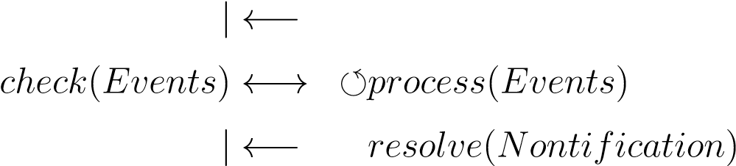| *triggerEvents*(*Notification*) *send*(*Events*)

The *UTM authority* (master) sends a notification about a dangerous situation or a directive for one or multiple *UAS*(slaves). The *UAS* receive *Notification/Directive*, this can trigger multiple events on UAS side. The *triggered Events* are notified to *UTM* (master). Then *UAS* process events and *UTM* checks the outcome. Once *events* from notification are resolved, the *UAS* will send out *resolution notification*.

The presented communication schema requires to implement following mechanisms to ensure concept flexibility:

1. *UTM notification mechanism* - to notify some airspace changes it is necessary to implement a minimal detection mechanism and to send necessary data for *slave event handling* system. The *UTM* should also cover mechanisms for *fail-safe* directives fulfillment check.
2. *UAS rule engine* - The UAS *Navigation/Detect & Avoid* systems must have some level of flexibility. The processing of some events are changing with time and having a static structure of event handling is obsolete. The *rule engine* with well-defined process decision points is a modern approach to event handling.

**Threat Hierarchy:** The *Threat Hierarchy* depends on the *airspace type* and its decided by *rules and regulations*, sometimes by common sense. The *hierarchy* goes like follow:

→ *Controlled Airspace* - there should be no static obstacles; usually the *airspace* is controlled from flight levels where is no presence of *permanent structures*.

→ *Air Traffic Control Restrictions* - there are restrictions of *airspace corridors* or *portions*. These restrictions are over*all* following and can not be broken without causing a serious security incident.

→ *Weather Restrictions (Critical Conditions)* - there are static or moving areas of bad weather, which impact can harm the UAS to the point of no recovery. These areas can be classified as *hard constraints*.

→ *UAS Traffic Management Restrictions* - there are static or moving areas which are prohibited from entering by *UTM* authority. They are similar to *Air Traffic Control* restrictions. The *restricted space* is prohibited from entering by *UAS*, but it can contain or be entered by *manned aviation*.

*Note.* The pilot community statement to UAS integration is to have preferential treatment to manned aviation.

→ *Non-cooperative Intruders* - the *intruding UAS* or *bird is* entering into the *controlled portion*. These need to be avoided without using *cooperative* capabilities.

→ *Weather Restrictions (Breachable Conditions)* - there are weather impacted areas where the *w*eather impact is not fatal to UAS (humidity resistance, wind resistance, improved exoskeleton). These impacted areas can be entered if its safe and cost-effective for the UAS. These type of restrictions are considered as *soft constraints* because they can be broken without significant drawback.

→ *Non-Controlled Airspace* - there is an addition of *static obstacles* and *geo-fencing* threats to UAS, some of the *controlled airspace aspects* are relaxed.

→ *Static obstacles* - there is terrain and man-made structures which are considered static in UAS mission time frame. These need to be avoided with the highest priority. They are usually detected with *UAS Sensors*.

→ *Intruders* - there can be intruders who do not have an intention to harm the *UAS*. These intruders can be handled the same way as in term of *controlled airspace*.

→ *Geo-fencing* - there are important structures or natural formations which are protected against the entrance of a *UAS*. The protection zone can have different shapes and can impact different altitudes even in *Controlled Airspace*. These zones can be considered *hard constraints* or *soft constraints* depending on the situation.

→ *Weather Restrictions (Critical/Breachable Conditions)* - the weather have the same impact as in *controlled airspace*. The *weather* in non-controlled airspace can be considered as *hard constraints* or *soft constraints* depending on the situation.

**Minimal Operational Data Set:** The *operational equipment* should be at least on the *manned aviation* grade. The *minimal* Instrumental Flight Rules (IFR) equipment was outlined in (sec. 2.3.2). The minimal operational data set can be defined through mandatory equipment, the listing goes as follow:

1. *Precise positioning* - the precise and real-time position for UAS are mandatory for precise navigation and precise position notifications.
2. *Self Identification Service* - each UAS needs to provide own identity, sharing position information and intentions information. The unique identifier and registration are mandatory to provide UAS ownership and responsibility link.
3. *Barometric Altitude* - the precise measurement for barometric altitude is necessary to enter into *controlled airspace*. The reference barometric pressure is provided by *Air Traffic Services* for selected airport/national airspace.
4. *Terrain Sensor* - the ability to avoid static obstacles and terrain is necessary for *low altitude operations*.
5. *Transponder (Cooperative Intruders Sensor)* - a complement to *self-identification service* and *position notification*. All mentioned functionality is covered by single device ADS-B In/Out.
6. *Non-cooperative Intruders Sensor* - the identification and extraction of non-cooperative intruders (hobby UAVs, birds) is increasing overall safety.

### 2.6.1 Mid-Air Collision Prevention

**Idea:** The first fatal mid-air collision occurred in 1912. The occurrence rate increased with technological progress. The *European airspace management* is thoroughly analyzed in [43].

*Mid-Air Collision Situations:* The most common situations when *Mid Air Collision* occurs are:

1. *Approach* (airport landing sequence) - the traffic density is increasing with proximity to traffic hub (airport). The aircraft lower velocity in early approach phase to a critical level which significantly reduces maneuverability. The *final approach* phase is most dangerous because the aircraft is close to the ground prepare for the landing.
2. *Descent* (decrease of altitude) - the pilot is heading plane down, the dead angle is much greater than in other situations.
3. *Cruise* (keeping the same altitude) - the pilot is keeping the altitude and heading, the awareness usually decreases significantly in this slight phase.
4. *Climb* (an increase of altitude) - the pilot is heading plane up, the dead angle is increased significantly.

*Note.* The *Mid-Air Collision* occurrence is strongly correlating with *traffic density*. Therefore the most of *near-miss /collision cases* happen in the vicinity of the airport. It is expected to elevate the risk of *Mid-Air Collision* by enabling *UAS* into *B, C, D, airports class* airspace.

**Collision Situation Awareness:** The surveillance capability of manned aviation is limited by the *pilot‘s field of vision* in case of VFR (sec. 2.3.1) and by *technical limitations* in case of IFR (sec. 2.3.2). The *surveillance and avoidance* support systems like TCAS (sec. 2.4.3) and ACAS (sec. 2.4.2) can be used as a base of future *DAA* system.

The *UAS* collision situation awareness system is taking the *mid-air* collision prevention to another level; additional functionality needs to be implemented:

1. *Intruder trajectory prediction* - anticipate future *intruder actions* based on gathered knowledge. Recognize dangerous actions or triggering situations. The pilot in manned aviation processes the triggering events of future dangerous situations.
2. *Intruder intersection model* - anticipate future maneuverability and physical properties (turbulence, body size) in intersection model of the intruder and try to estimate an impact area in future. This process is done by the pilot in manned aviation. Some supplementary information like *aircraft type* and some properties are provided by the surveillance system. The final decision and estimate need to be automatized in the form of impact probability or impact rating.
3. *Decision-making process* - the situation assessment gives an outline of the surrounding space properties, this process is well covered by *surveillance*. The decision-making process needs to be flexible and adaptable, but the limited computational resources need to be taken into account (discretization problem).

*Note.* The *example* of *enclosed operational space* which is necessary for *intruder intersection* detection is given in [44].

### 2.6.2 Weather Impact

**Idea:** The *climate* has stable properties throughout the year. There are observations that climate is shifting in Europe, the periods of sprint/autumn weather are shortening, the periods of summer and winter are prolonging.

Overall the *European Climate* is getting similar to *North America‘s* continental climate. This has a severe impact on many aspects of modern society including transportation, especially aviation, emerging UAS industry.

The key fact is that the occurrence of critical weather conditions, like storms or heavy winds is increasing. Along with the increasing intensity of these events, the magnitude increases to non-construction mitigable levels.

**Transportation Impact:** The *train transportation* is the most robust and very infrastructure dependant transportation type. On the other hand, the *aerial transportation* infrastructure is sparse, and most of the maneuvering is done in open airspace.

*Weather Impact* on transportation, in general, has been introduced by Koetse in the study [45]. The *bad weather* situations are well avoidable by *general aviation*. The *general aviation* avoidance capability comes from the *high organization* of controlled *airspace*, high grade of surveillance equipment (weather radar).

The situation with *UAS* systems is different; they usually have more delicate construction and significantly smaller takeoff weight. The *weather* could be even harsher on the lower altitudes. The *implementation* of *weather avoidance* is necessary for *safe UAS operations* in non-controlled airspace. The *UAS operations* can stick to existing weather avoidance approaches in controlled airspace.

The *challenge* to avoid weather situations is similar to the geo-fencing problem on low altitudes. The *serious weather case* can be encapsulated into a protected area with some *altitude limitations*.

**Weather avoidance:** *Weather-based* preemptive planning was introduced into manned aviation in 2015 [46]. There is a global approach to weather avoidance. Meaning there is one global *weather model*. Similar impact on every *controlled airspace* attendant. This impact model needs to be refined for various *aircraft classes*.

*Note.* The *UAS classes* are summarized in (tab. 2.3), the *separation minima* is specified in (tab. 2.4). This needs to be accounted in weather impact calculation.

The *separation minima* are also accounted for *weather* separation. The *UAS* must keep minimal distance to *dangerous weather condition*.

The radius and impact zone of *dangerous weather condition* is evaluated concerning *UAS* class; the 5 kg machine is more impacted than 150 kg machine or *autonomous personal transportation*.

*Severe Weather Condition Detection Capabilities* for the current level of standard aviation equipment have been reviewed in [47]. The capability is sufficient for medium scale *UAS* (25 kg). The *numeric models* for *local airspace cluster* can have precision up to one cubic meter of air. The precision of *numeric prediction* depends *weather stations* density and equipment precision.

The *dynamic* routing of *aircraft* (manned aviation) has been outlined in Balaban et al. [48]. The operational space is separated into *altitude layers* where each layer is separated into homogeneous euclidean grid cells. Each cell (fig. 2.7) has an evaluation of *relative humidity* (fig. 2.7a), *temperature*, *wind velocity and heading* (fig.2.7b). There is possible to make a prediction and route all aircraft in advance. The scaling challenge also remains for this approach.

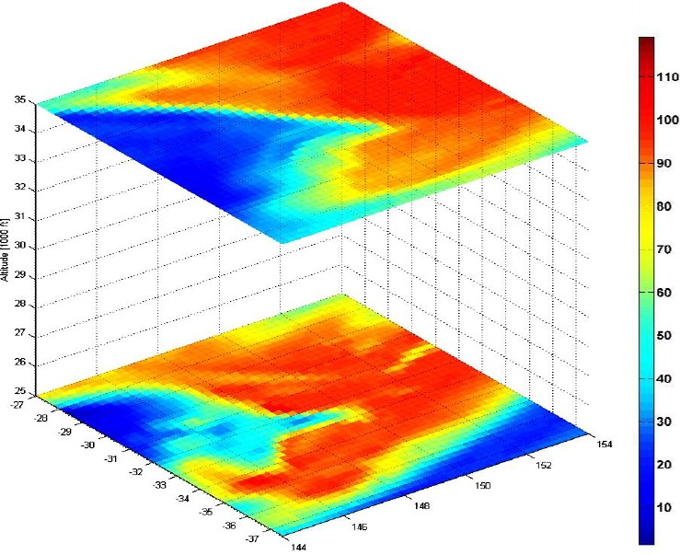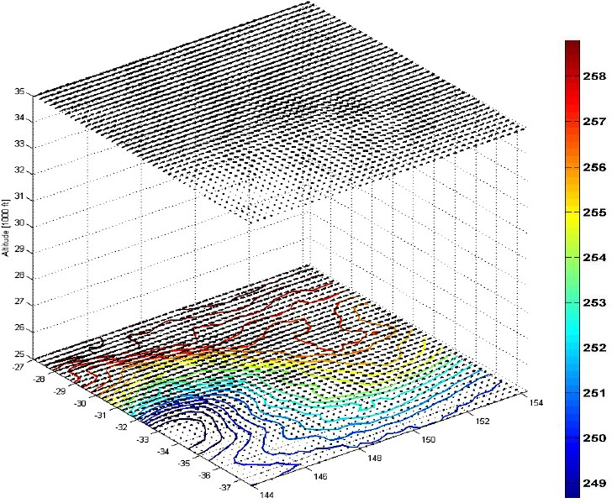

(a) Relative Humidity. (b) Localized Wind Vectors.

Figure 2.7: Localized Weather Model [48].

**Localized Weather Impact Example:** An *Icing Risk* in a localized environment have been predicted based on the numerical model [49]. It is shown that icing can be prevented by *planned* and *reactive* avoidance. The prevention can be done by placing hard or soft constraint into an environment.

**Weather Models:** *Weather Models* can be extracted from *Climate and weather model archive at the National Oceanic and Atmospheric Administration* [50]. There is an example of troposphere winds (0 - 60 000 feet AMSL) (fig. 2.8) which can be useful in fuel-efficient route planning.

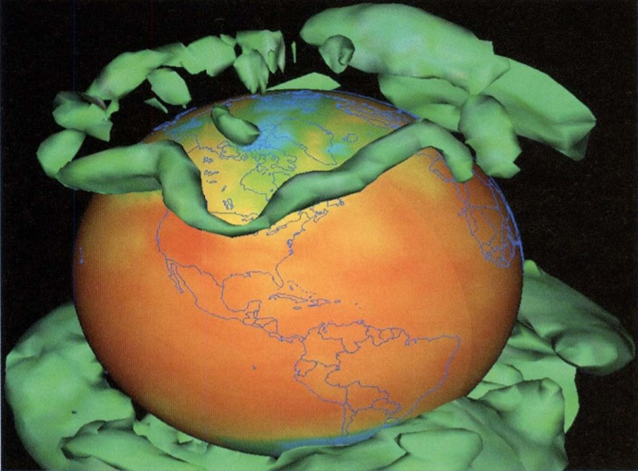

Figure 2.8: Example of upper troposphere winds [50].

# Bibliography

1. Alessandro Gardi, Roberto Sabatini, Subramanian Ramasamy, Matthew Marino, et al. Automated atm system for 4-dimensional trajectory based operations. In *AIAC16: 16th Australian International Aerospace Congress*, page 190. Engineers Australia, 2015.
2. Artur Zolich, David Palma, Kimmo Kansanen, Kay Fjørtoft, Jo˜ao Sousa, Karl H. Johansson, Yuming Jiang, Hefeng Dong, and Tor Johansen. Survey on communication and networks for autonomous marine systems. *Journal of Intelligent & Robotic Systems*, page tba, 04 2018.
3. Francesco Nex and Fabio Remondino. Uav for 3d mapping applications: a review. *Applied geomatics*, 6(1):1–15, 2014.
4. William Kress Bodin, Jesse Redman, and Derral Charles Thorson. Navigating a uav with obstacle avoidance algorithms, June 5 2007. US Patent 7,228,232.
5. Jonathan P How, BRETT BEHIHKE, Adrian Frank, Daniel Dale, and John Vian. Real-time indoor autonomous vehicle test environment. *IEEE control systems*, 28(2):51–64, 2008.
6. Anouck R Girard, Adam S Howell, and J Karl Hedrick. Border patrol and surveillance missions using multiple unmanned air vehicles. In *Decision and Control, 2004. CDC. 43rd IEEE Conference on*, volume 1, pages 620–625. IEEE, 2004.
7. Fabio AA Andrade, Rune Storvold, and Tor Arne Johansen. Autonomous uav surveillance of a ship’s path with mpc for maritime situational awareness. In *Unmanned Aircraft Systems (ICUAS), 2017 International Conference on*, pages 633– 639. IEEE, 2017.
8. Kristian Klausen, Thor I Fossen, and Tor Arne Johansen. Nonlinear control with swing damping of a multirotor uav with suspended load. *Journal of Intelligent & Robotic Systems*, 88(2-4):379–394, 2017.
9. Thomas W Kennedy Jr and Donald F Fenstermaker. Resolution advisory display instrument for tcas guidance, January 17 1995. US Patent 5,382,954.
10. Mike Marston and Gabe Baca. Acas-xu initial self-separation flight tests, 2015.

41

*BIBLIOGRAPHY*

1. Jon A Blaskovich and Stephen G McCauley. Declutter of graphical tcas targets to improve situational awareness, December 11 2007. US Patent 7,307,578.
2. Roberto Sabatini, Alessandro Gardi, and Mark A Richardson. Lidar obstacle warning and avoidance system for unmanned aircraft. *International Journal of Mechanical, Aerospace, Industrial and Mechatronics Engineering*, 8(4):702–713, 2014.
3. Subramanian Ramasamy, Roberto Sabatini, Alessandro Gardi, and Jing Liu. Lidar obstacle warning and avoidance system for unmanned aerial vehicle sense-and-avoid. *Aerospace Science and Technology*, 55:344–358, 2016.
4. Subramanian Ramasamy, Roberto Sabatini, and Alessandro Gardi. Avionics sensor fusion for small size unmanned aircraft sense-and-avoid. In *Metrology for Aerospace (MetroAeroSpace), 2014 IEEE*, pages 271–276. IEEE, 2014.
5. John D Lee, Daniel V McGehee, Timothy L Brown, and Michelle L Reyes. Collision warning timing, driver distraction, and driver response to imminent rear-end collisions in a high-fidelity driving simulator. *Human factors*, 44(2):314–334, 2002.
6. Ronald Miller and Qingfeng Huang. An adaptive peer-to-peer collision warning system. In *Vehicular technology conference, 2002. VTC Spring 2002. IEEE 55th*, volume 1, pages 317–321. IEEE, 2002.
7. Lisa C Thomas, Christopher D Wickens, and IL Savoy. Effects of cdti display dimensionality and conflict geometry on conflict resolution performance. In *Proceedings of the 13th International Symposium on Aviation Psychology*. Citeseer, 2005.
8. David H Williams. Self-separation in terminal areas using cdti. In *Proceedings of the Human Factors Society Annual Meeting*, volume 27, pages 772–776. Sage Publications Sage CA: Los Angeles, CA, 1983.
9. ICAO. Annex 11 (air traffic services). Technical report, ICAO, 2018.
10. ICAO. 4444: Procedures for air navigation services. Technical report, ICAO, 2018.
11. Civil Aviation Safety Authority. Human injury model for small unmanned aircraft impacts, 2013.
12. Roland Weibel and R John Hansman. Safety considerations for operation of different classes of uavs in the nas. In *AIAA 4th Aviation Technology, Integration and Operations (ATIO) Forum*, page 6244, 2004.
13. ICAO. Annex 2 (rules of the air). Technical report, ICAO, 2018.
14. ICAO Doc. 8168 ops/611 aircraft operations: Procedures for air navigation servicesvolume ii construction of visual and instrument flight procedures, 2006.

*BIBLIOGRAPHY* 43

1. Commission implementing regulation (eu) no 923/2012. obtained from:

[https://eur-lex.europa.eu/LexUriServ/LexUriServ.do?uri=OJ:L:2012:](https://eur-lex.europa.eu/LexUriServ/LexUriServ.do?uri=OJ:L:2012:281:0001:0066:EN:PDF)

[281:0001:0066:EN:PDF](https://eur-lex.europa.eu/LexUriServ/LexUriServ.do?uri=OJ:L:2012:281:0001:0066:EN:PDF) on 15th November 2018, February 2017.

1. Kimon P Valavanis and George J Vachtsevanos. Uav sense, detect and avoid: Introduction. In *Handbook of Unmanned Aerial Vehicles*, pages 1813–1816. Springer, 2015.
2. United States. Federal Aviation Administration. *Pilots’ Role in Collision Avoidance*. Number 48 in 1. US Department of Transportation, Federal Aviation Administration, 1983.
3. Alessandro Gardi, Roberto Sabatini, Subramanian Ramasamy, and Trevor Kistan. Real-time trajectory optimisation models for next generation air traffic management systems. In *Applied Mechanics and Materials*, volume 629, pages 327–332. Trans Tech Publ, 2014.
4. Ingrid Gerdes, Annette Temme, and Michael Schultz. Dynamic airspace sectorization using controller task load. *Sixth SESAR Innovation Days*, 2016.
5. EUROCONTROL NETALERT. N17-acas x-the future of airborne collision avoidance, 2013.
6. ICAO Annex. 10-vol. 4 - aeronautical telecommunications, surveillance radar and collision avoidance systems, 2007.
7. Federal Aviation Administration. Introduction to tcas ii, version 7.1. 2011.
8. C´esar Munoz, Anthony Narkawicz, and James Chamberlain. A tcas-ii resolution advisory detection algorithm. In *AIAA Guidance, Navigation, and Control (GNC) Conference*, page 4622, 2013.
9. Remotely piloted aircraft systems atm concept of operations. obtained from: [https://www.eurocontrol.int/publications/](https://www.eurocontrol.int/publications/remotely-piloted-aircraft-systems-rpas-atm-concept-operations-conops)

[remotely-piloted-aircraft-systems-rpas-atm-concept-operations-conops](https://www.eurocontrol.int/publications/remotely-piloted-aircraft-systems-rpas-atm-concept-operations-conops) on 14th November 2018, February 2017.

1. EASA. Prototype commission regulation on unmanned aircraft operations. obtained from: [https://www.easa.europa.eu/sites/default/files/dfu/UAS% 20Prototype%20Regulation%20final.pdf](https://www.easa.europa.eu/sites/default/files/dfu/UAS%20Prototype%20Regulation%20final.pdf) on 14th November 2018, August 2016.
2. Andrew Hately. Concept of Operations for U-space. Eurocontrol draft., June 2018.
3. European Commision. Regulation (ec) no 923/2012 of the european parliament and of the council of 26 september 2012 laying down common common rules of the air... including amendment by regulation (ec) no 1185/2016 of 20 july 2016.

*BIBLIOGRAPHY*

obtained from: [http://eur-lex.europa.eu/legalcontent/EN/TXT/?uri=CELEX: 02012R0923-20171012](http://eur-lex.europa.eu/legalcontent/%20EN/TXT/?uri=CELEX:02012R0923-20171012) on 11th November 2018, July 2012.

1. European Commision. Regulation (ec) no 216/2008 of the european parliament and of the council of 20 february 2008 on common rules in the field of civil aviation and establishing a european aviation safety agency. obtained from: [http://eur-lex. europa.eu/legal-content/en/ALL/?uri=CELEX%3A32008R0216](http://eur-lex.europa.eu/legal-content/en/ALL/?uri=CELEX%3A32008R0216) on 11th November 2018, February 2008.
2. EASA. Easa opinion 01-2018. obtained from: [https://www.easa.europa.eu/ document-library/opinions/opinion-012018](https://www.easa.europa.eu/document-library/opinions/opinion-%20012018) on 11th November 2018, January 2018.
3. Andrew C Cone, David P Thipphavong, Seung Man Lee, and Confesor Santiago. Uas well clear recovery against non-cooperative intruders using vertical maneuvers. In *17th AIAA Aviation Technology, Integration, and Operations Conference*, page 4382, 2017.
4. Seung Man Lee, Chunki Park, Andrew Clayton Cone, David P Thipphavong, and Confesor Santiago. Nas-wide fast-time simulation study for evaluating performance of uas detect-and-avoid alerting and guidance systems. 2016.
5. David Thipphavong, Andrew Cone, and Seungman Lee. Ensuring interoperability between unmanned aircraft detect-and-avoid and manned aircraft collision avoidance. 2017.
6. Andrew Cook. *European air traffic management: principles, practice, and research*. Ashgate Publishing, Ltd., 2007.
7. Emo Welzl. Smallest enclosing disks (balls and ellipsoids). In *New results and new trends in computer science*, pages 359–370. Springer, 1991.
8. Mark J Koetse and Piet Rietveld. The impact of climate change and weather on transport: An overview of empirical findings. *Transportation Research Part D: Transport and Environment*, 14(3):205–221, 2009.
9. Hiroshi Yamashita, Volker Grewe, Patrick Jo¨ckel, Florian Linke, M Schaefer, and D Sasaki. Climate impact assessment of routing strategies: Interactive air traffic in a climate model. *Climate Proceedings*, 2015.
10. Travis M Smith, Valliappa Lakshmanan, Gregory J Stumpf, Kiel L Ortega, Kurt Hondl, Karen Cooper, Kristin M Calhoun, Darrel M Kingfield, Kevin L Manross, Robert Toomey, et al. Multi-radar multi-sensor (mrms) severe weather and aviation products: Initial operating capabilities. *Bulletin of the American Meteorological Society*, 97(9):1617–1630, 2016.

*BIBLIOGRAPHY* 45

1. Edward Balaban, Indranil Roychoudhury, Lilly Spirkovska, Shankar Sankararaman, Chetan S Kulkarni, and Matthew Daigle. Dynamic routing of aircraft in presence of adverse weather using a pomdp framework. In *17th AIAA Aviation Technology, Integration, and Operations Conference*, page 3429, 2017.
2. Gregory Thompson, Marcia K Politovich, and Roy M Rasmussen. A numerical weather model’s ability to predict characteristics of aircraft icing environments. *Weather and Forecasting*, 32(1):207–221, 2017.
3. Glenn K Rutledge, Jordan Alpert, and Wesley Ebisuzaki. Nomads: A climate and weather model archive at the national oceanic and atmospheric administration.

*Bulletin of the American Meteorological Society*, 87(3):327–341, 2006.

1. Australian airspace classification: [http://www.airservicesaustralia.com/services/ how-air-traffic-control-works/how-airspace-is-managed/](http://www.airservicesaustralia.com/services/how-air-traffic-control-works/how-airspace-is-managed/)
2. Czech Republic Airspace Classification:<https://lis.rlp.cz/vfrmanual/actual/enr_1_en.html>
3. The live map for Czech National Airspace can be viewed on: <http://aisview.rlp.cz/>
4. Czech republic AIP 1.1 document: <https://lis.rlp.cz/ais_data/aip/data/valid/e1-2.pdf>
5. Related research and articles: <https://utm.arc.nasa.gov/documents.shtml>